City Write-Ups / Descriptions

NYC
City | Population | % White | Median Household Income | Mean Income | % Poverty | % Bachelor's Degree or Higher
New York, NY | 8,336,817 | 42.7% | $63,998 | $39,828 | 17.9% | 38.1%

NYC is one of the largest cities, one of the most metropolitan cities, a huge tourist city, an F500 city, one of the fastest gentrifying cities, and one of the most popular student cities. Its diversity extends across various ages, and its dense living forces the population to arrange itself into tight patterns of residence. Between NYC’s high property costs and dense population, the city should likely produce very robust patterns of segregation by wealth and influence, which may or may not also be linked to racial segregation. New York is uniquely informative on how strongly patterns of living can reflect privilege (because they likely result from economic pressure and property price disparity).
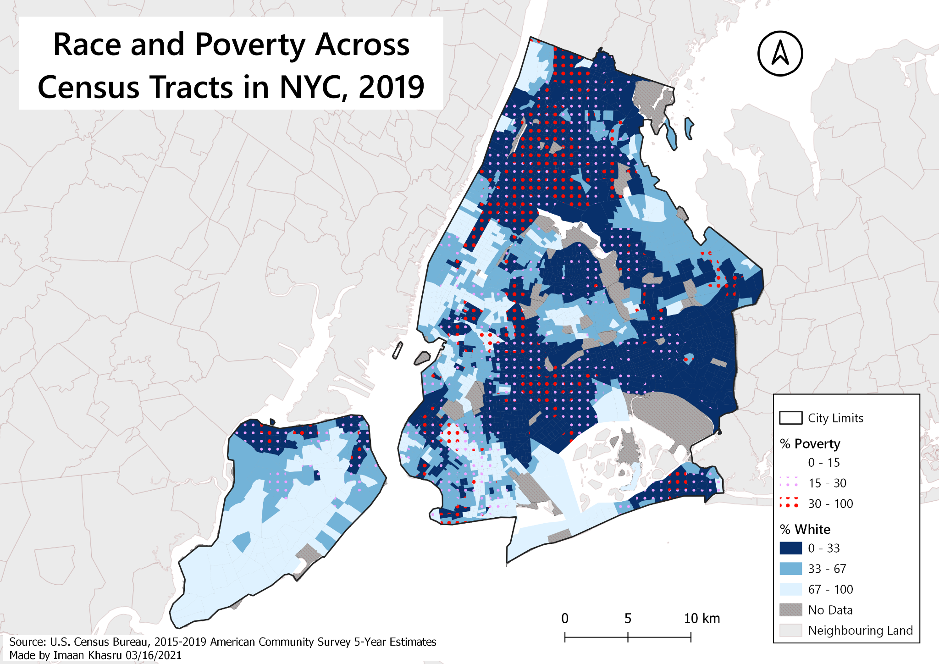

LA
City | Population | % White | Median Household Income | Mean Income | % Poverty | % Bachelor's Degree or Higher
Los Angeles, CA | 3,979,576 | 52.1% | $62,142 | $35,261 | 18.0% | 34.4%

Los Angeles is somewhat ethnically unique as a point of comparison for its large Asian-American population compared to most non-Californian cities in the rest of America. California is both highly racially diverse and economically diverse, making it an interesting case study for distribution of race and income across neighbourhoods. Furthermore, LA provides a contrast to many of the East Coast and Midwestern cities we look at, allowing for improved external validity by increasing our scope over more of America. It’s one of the most populous and most metropolitan cities of America, continuing on the theme of urban spatial analysis.
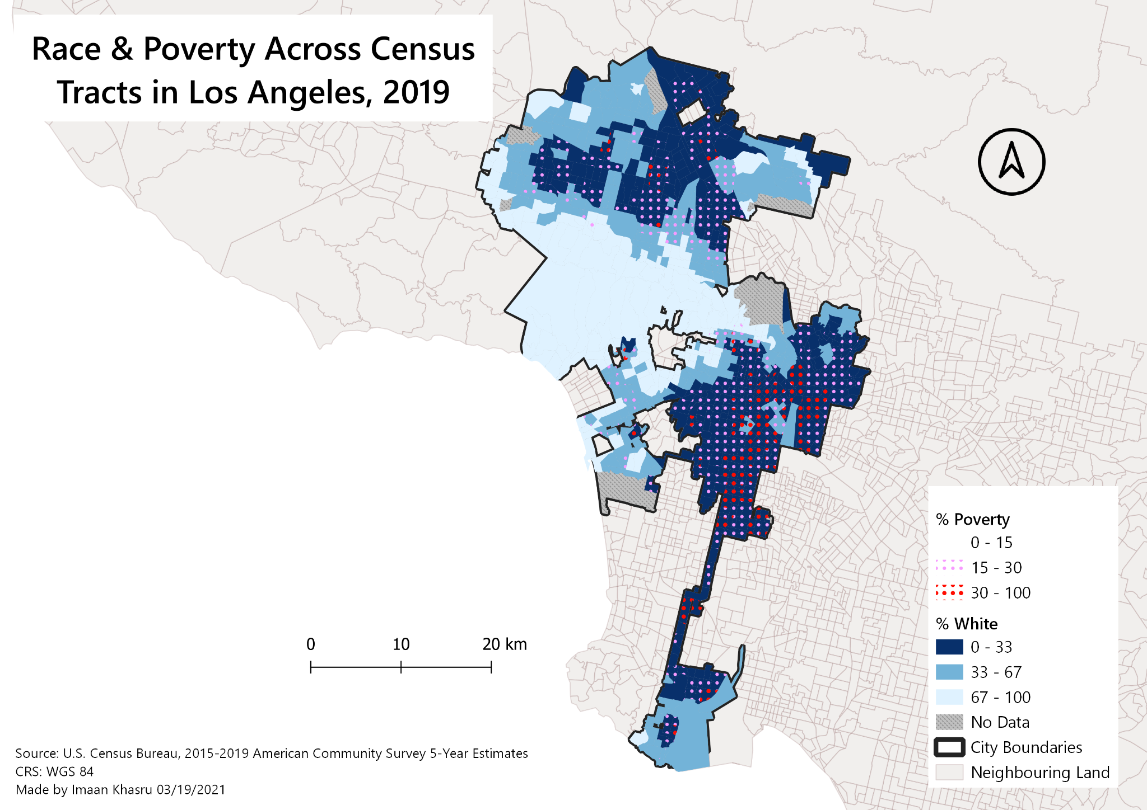

Chicago
City | Population | % White | Median Household Income | Mean Income | % Poverty | % Bachelor's Degree or Higher
Chicago, IL | 2,693,976 | 50.0% | $58,247 | $37,103 | 18.4% | 39.5%

Chicago’s one of the fastest gentrifying cities in America, making it an interesting stomping grounds for residential competition between different demographics of socioeconomic status (SES) and racial/ethnic background. Furthermore, its status as one of the largest (in terms of population) and most metropolitan cities allow for greater range of possible demographic arrangements across neighbourhoods, and speak to the economic pressure of urban living on neighbourhood arrangement.
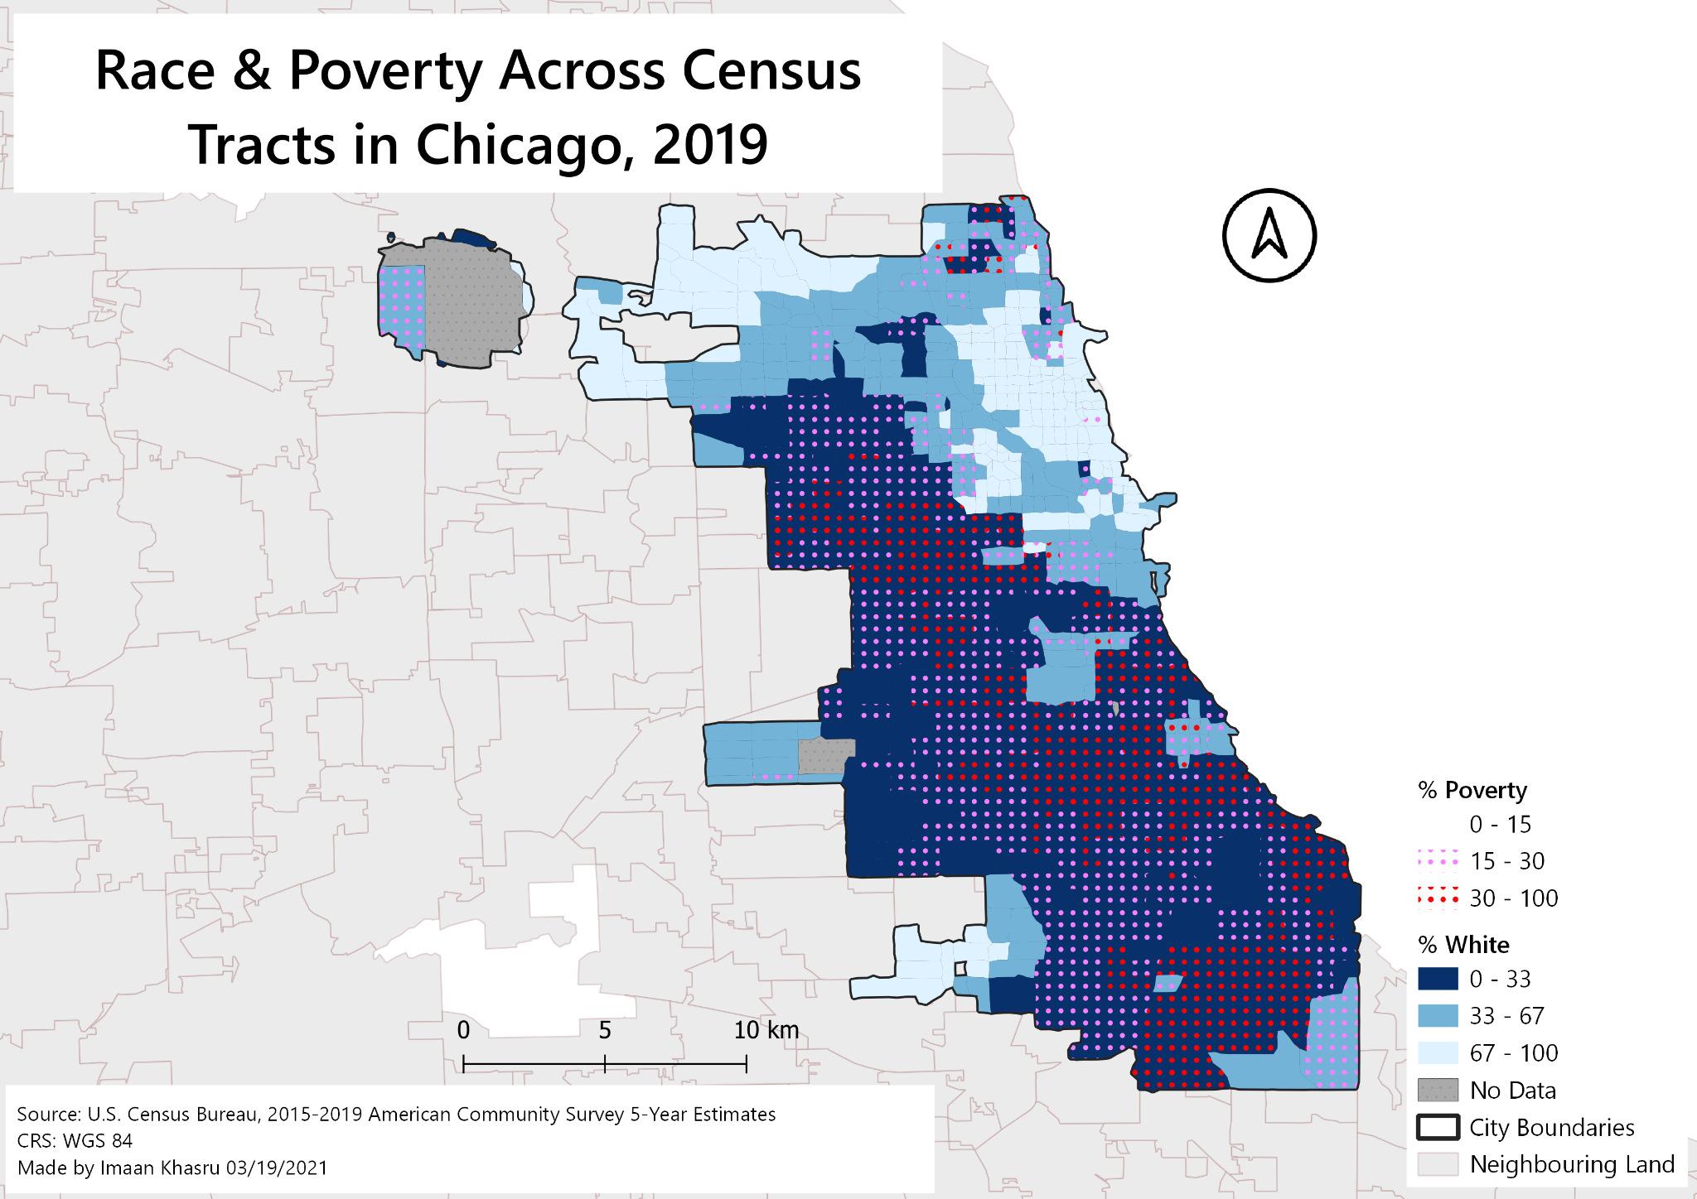

Houston
City | Population | % White | Median Household Income | Mean Income | % Poverty | % Bachelor's Degree or Higher
Houston, TX | 2,320,268 | 57.0% | $52,338 | $32,521 | 20.1% | 32.9%

A look into Houston offers an analysis of how distribution of race and income may vary across cities in the South, where clusters of Black and Hispanic/Latino populations reside. Houston is extremely populated, metropolitan, and one of few F500 cities in America. Its majority-white population offers interesting contrast to Philadelphia, New York City, and Atlanta.
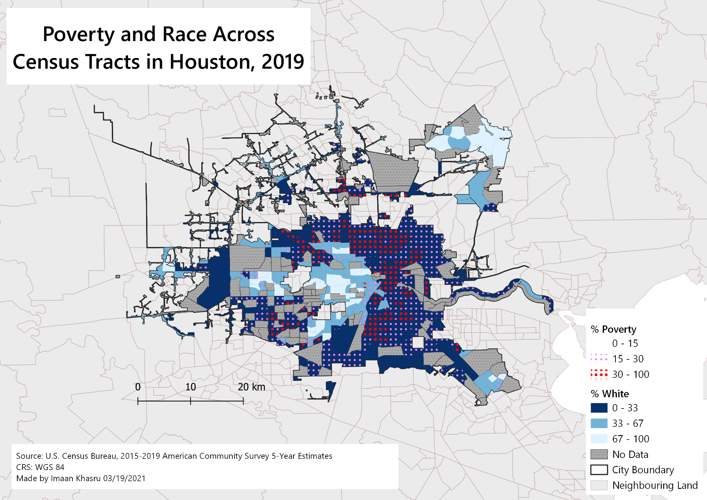

Philadelphia
City | Population | % White | Median Household Income | Mean Income | % Poverty | % Bachelor's Degree or Higher
Philadelphia, PA | 1,584,064 | 40.7% | $45,927 | $27,924 | 24.3% | 29.7%

Philadelphia is an excellent case for examining how racial and SES patterns distribute over neighbourhoods in a white-minority city. Its status as a very fast-gentrifying city with high levels of poverty make for an interesting redistribution of SES across neighbourhoods. Furthermore, it’s a popular student city (therefore its population varies quickly and consistently), and highly metropolitan.
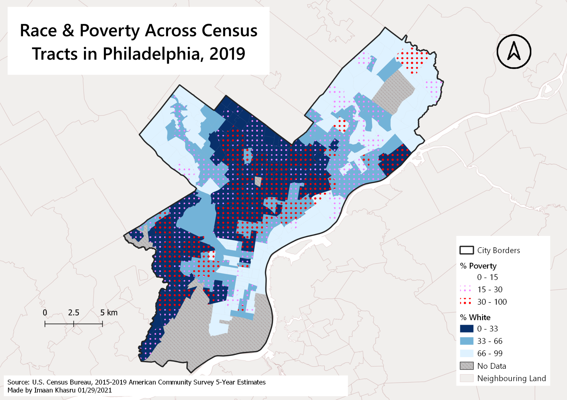

Dallas
City | Population | % White | Median Household Income | Mean Income | % Poverty | % Bachelor's Degree or Higher
Dallas, TX | 1,343,573 | 62.7% | $52,580 | $34,479 | 18.9% | 33.4%

Dallas is an urban hub, a popular tourist city, and an F500 city─ serving as a commercial centre for the region. Its population is diverse across race, income, and industry, and an interesting example having a white majority, but a black mayor. Dallas serves as a second Texan city to look at, increasing representation of the South in our analysis.

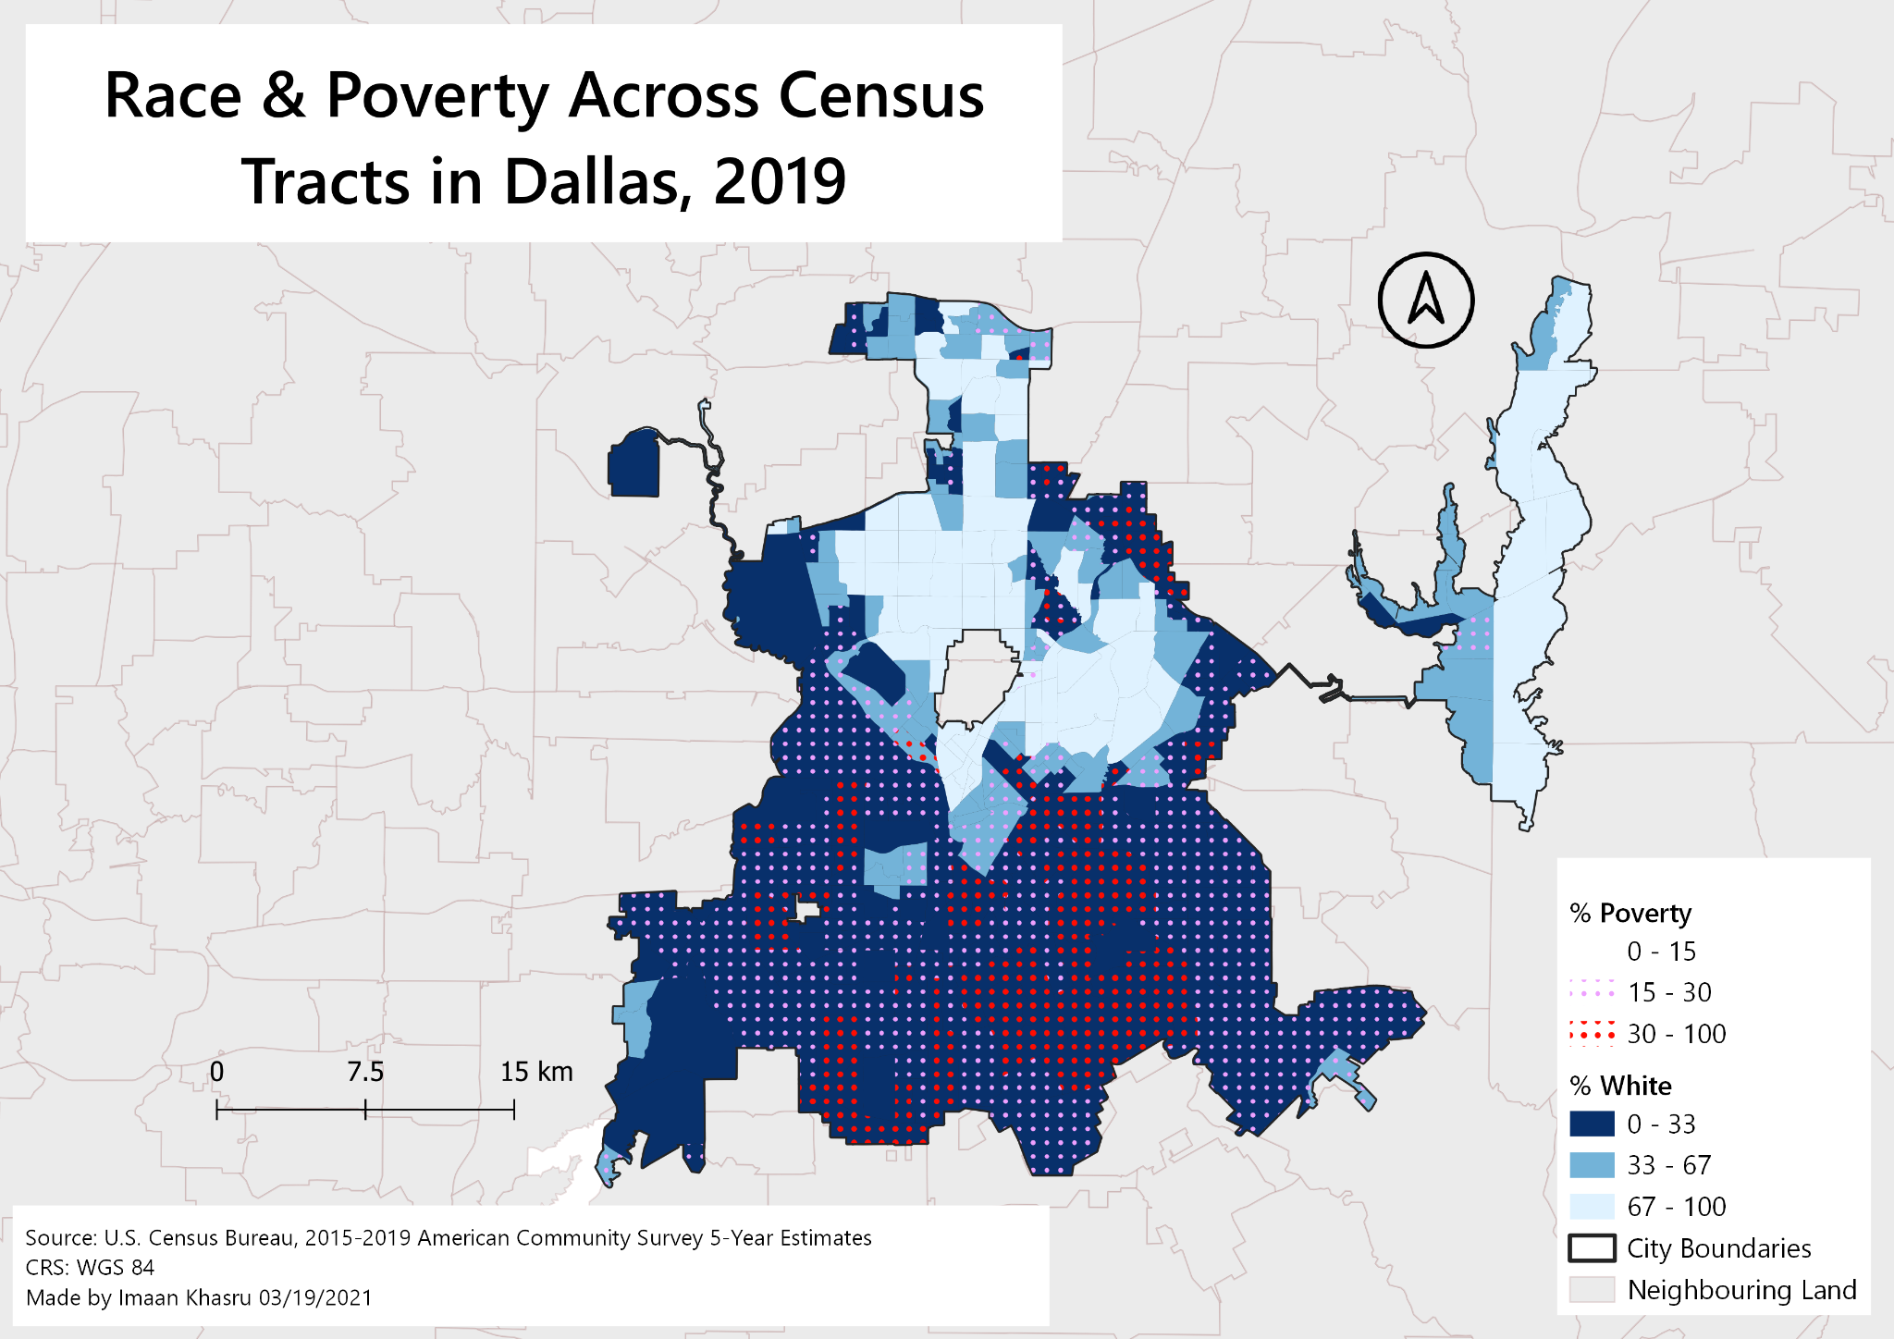

Atlanta
City | Population | % White | Median Household Income | Mean Income | % Poverty | % Bachelor's Degree or Higher
Atlanta, GA | 506,811 | 40.9% | $59,948 | $47,424 | 20.8% | 51.8%

Atlanta is a key example for understanding distribution of race and income across neighbourhoods, being a capital city, a fast-gentrifying city, and a black-majority city run by a black mayor. As the capital of the “New South,” Atlanta enjoys higher education and lower poverty rates than Texan cities Dallas and Houston. However, it at the same time has more of a black majority, signifying potential for neighbourhoods where increased presence of BIPOC communities may not correlate with an increase in poverty.



